G.RAVIKUMAR

CONFIGURATION AND MANAGING THE OC4J

in order to deploy the .ear files first you have login to the middtier application, check wheather
oc4J instances are up and running or not. Here we can deploy three files jar,war,ear.

managing oc4j using command line:
$opmnctl startproc ias-component=oc4j
$opmnctl stopproc ias-component=oc4j
$opmnctl statusproc ias-component=oc4j
suppose under oc4j component there is differenr process is there in order to stop the perticular
using process-type we can stop,start the perticular component.
$opmnctl startproc process-type=oc4j-test

how to create instance: first you have to connect to the midtier application. Then click on to create
oc4j _instance .
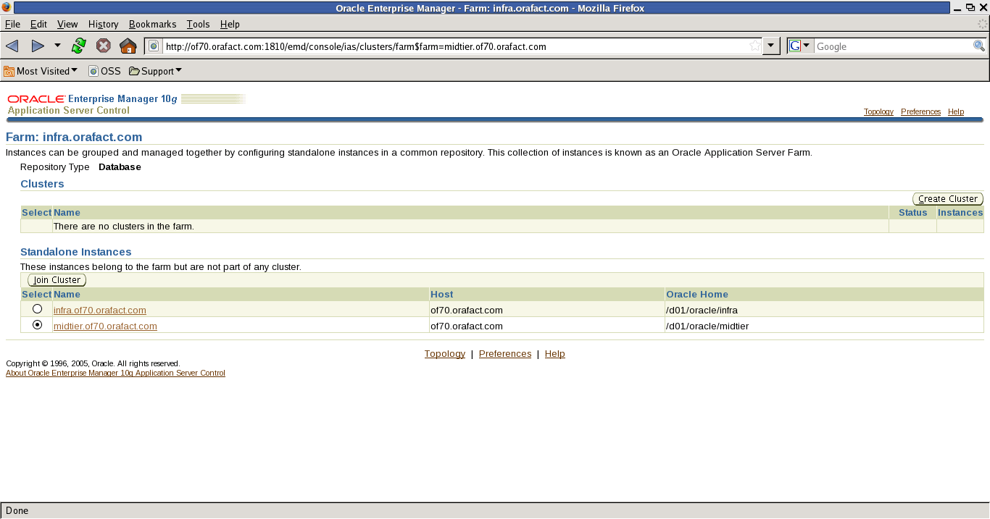

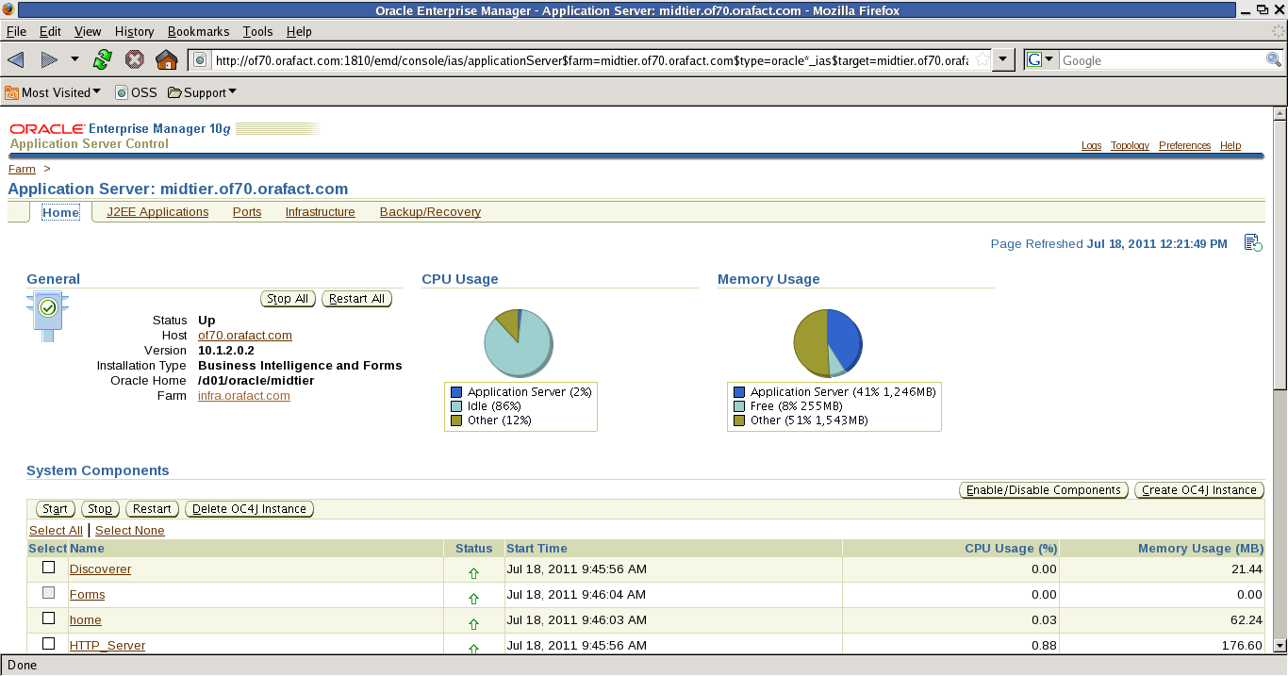
once you enter into the midtier application it shows the midtier components

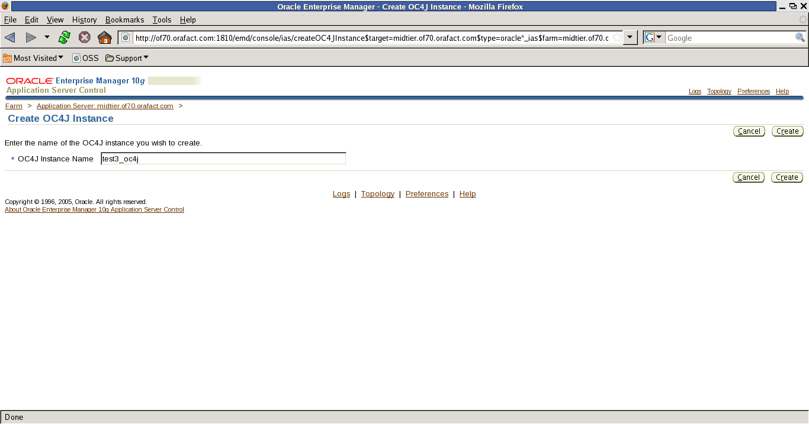
when you see above screen create oc4j instance ie enter the name of the instance.afer that clicking on ok your instance being created.

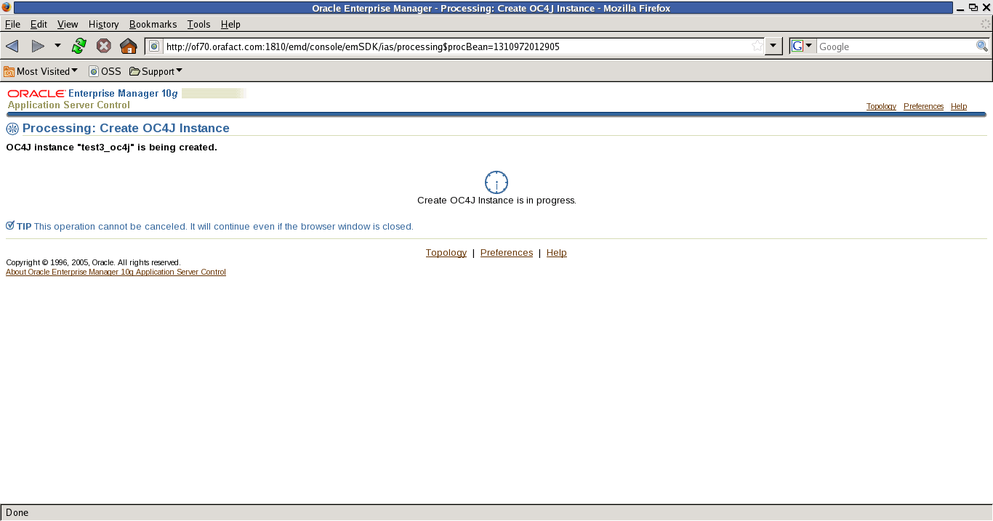
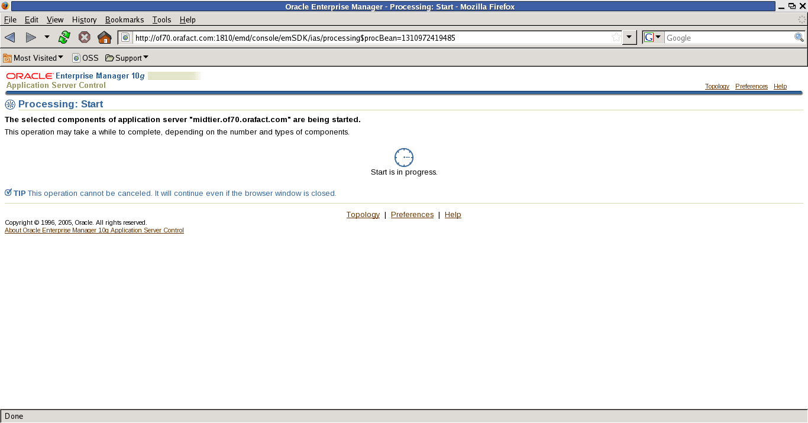

after creating oc4j_instane name when you enter into the midtier browser, it is showing down for that
you have check it in command line also.
By using this command: $opmnctl status
after you can start on browser selecting perticular component then click on start.

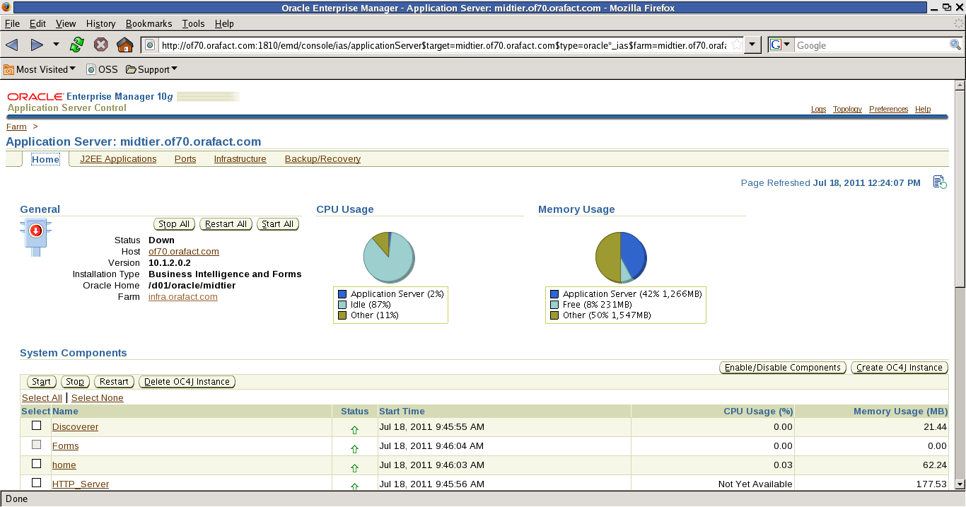
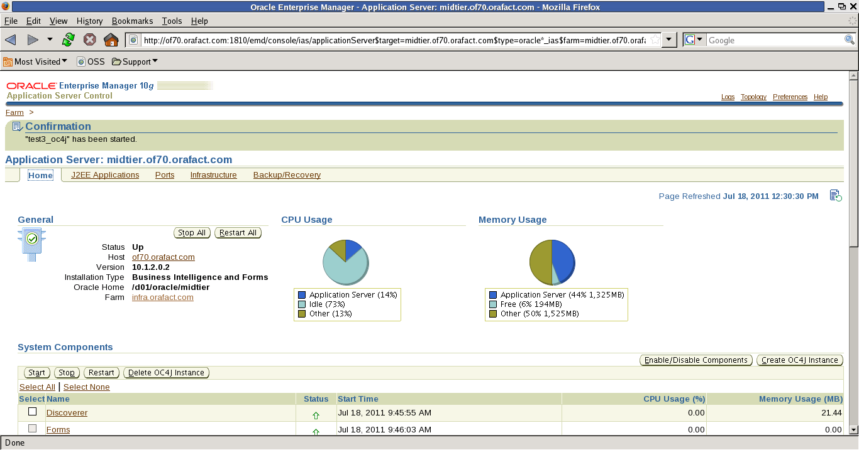

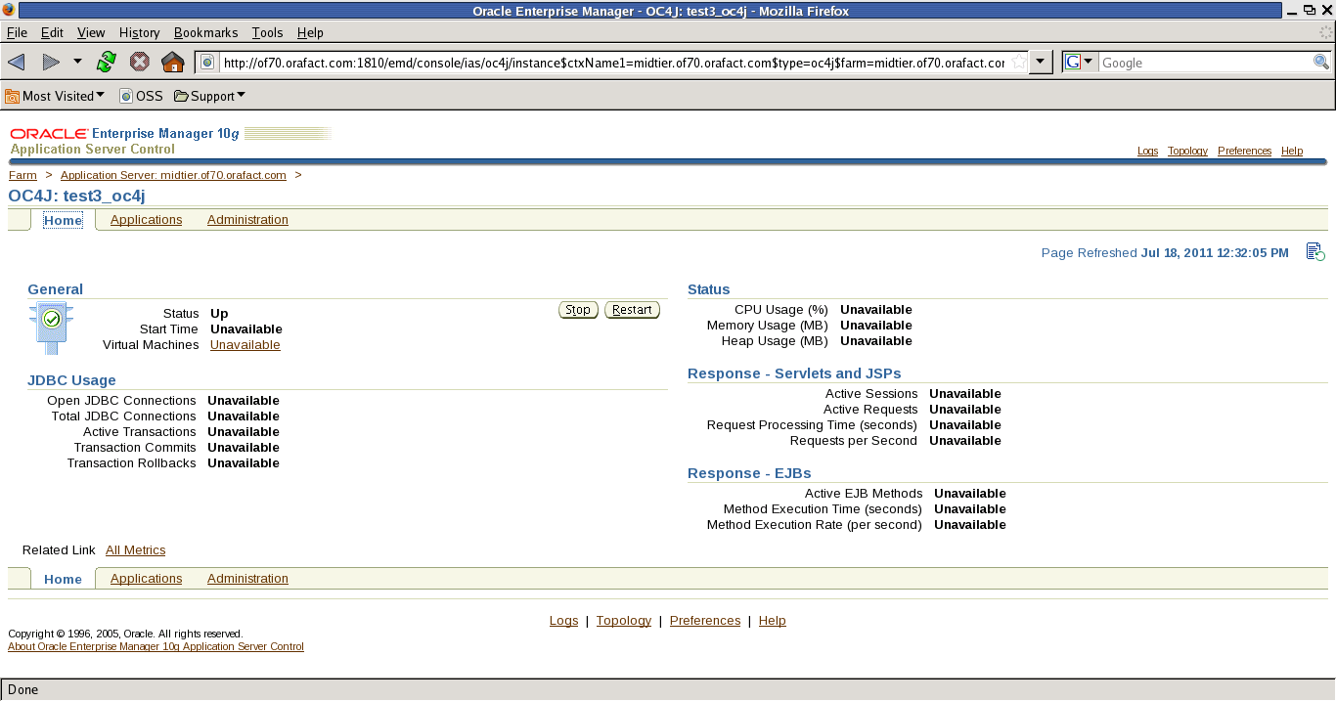
after starting the instance click on application tab then click on deploy ear file:

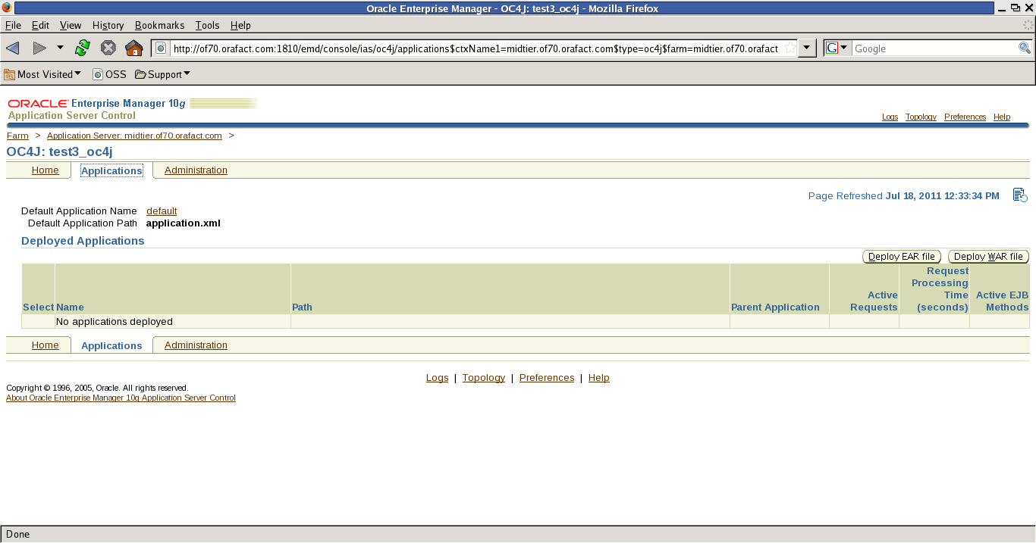

after clicking on deploy war file it asking the name of application where it located.then click on create.

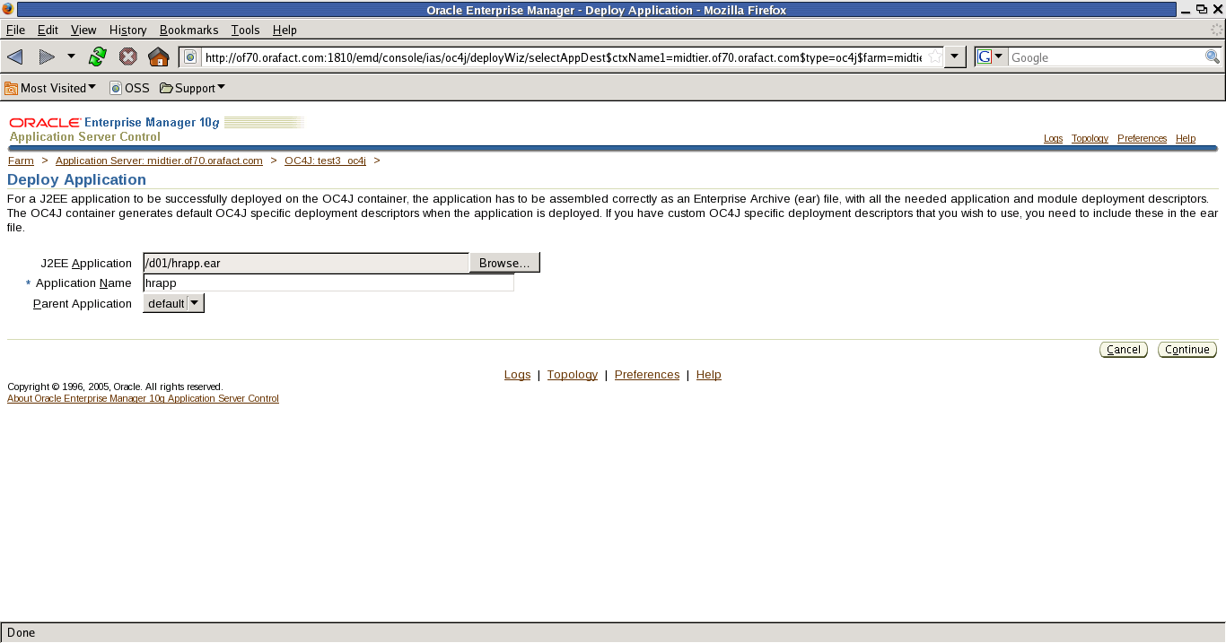

then in the next window it is asking URL NAME: using this name only you will get the application.
Then click on next.

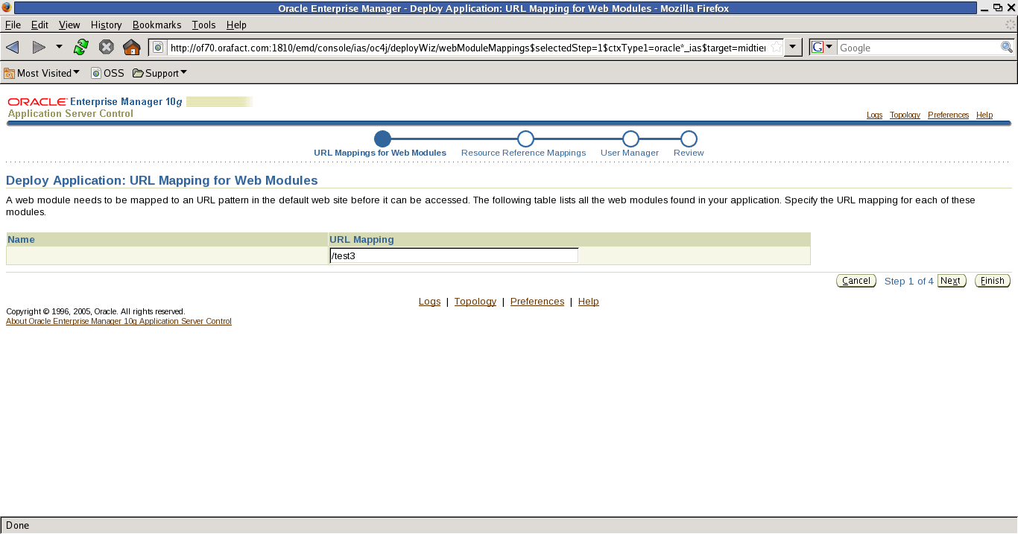

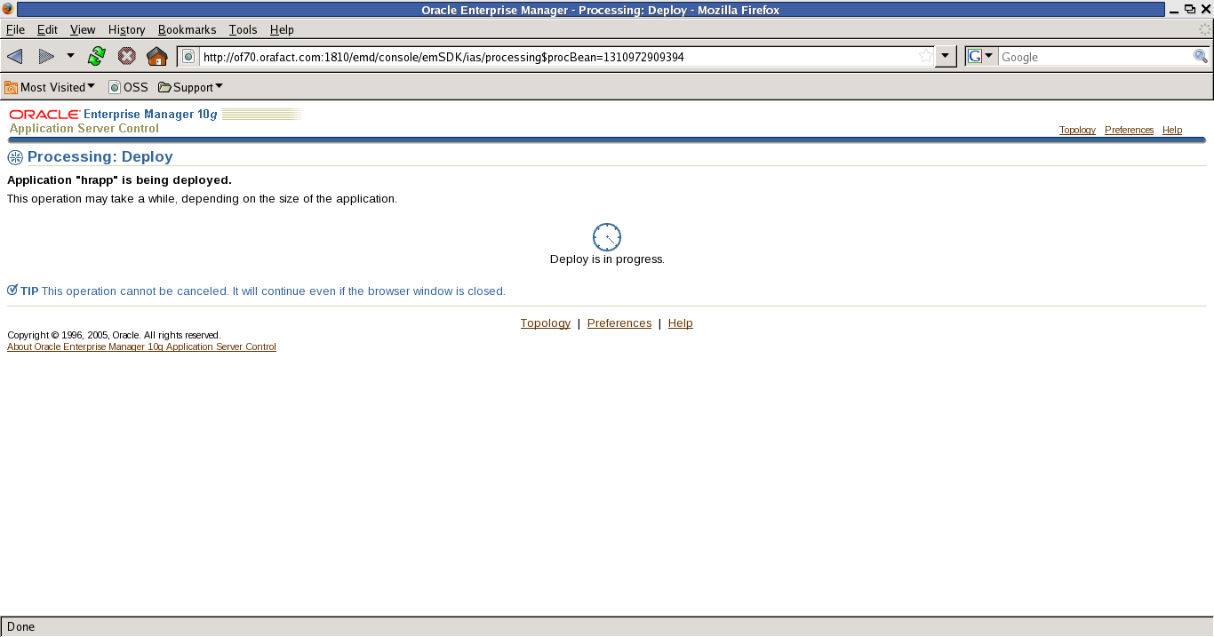

by clicking on ok it going to deploy the .ear file. Then it will give the confirmation, application
hrapp was successfully deployed.

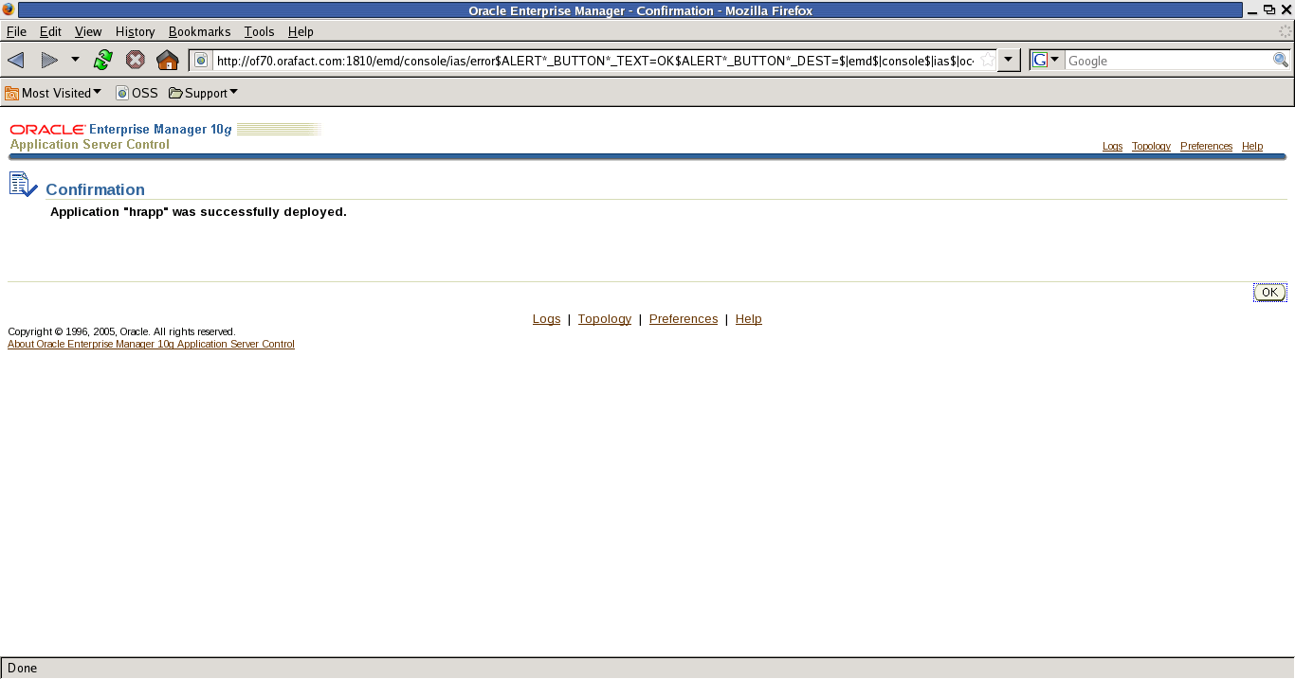

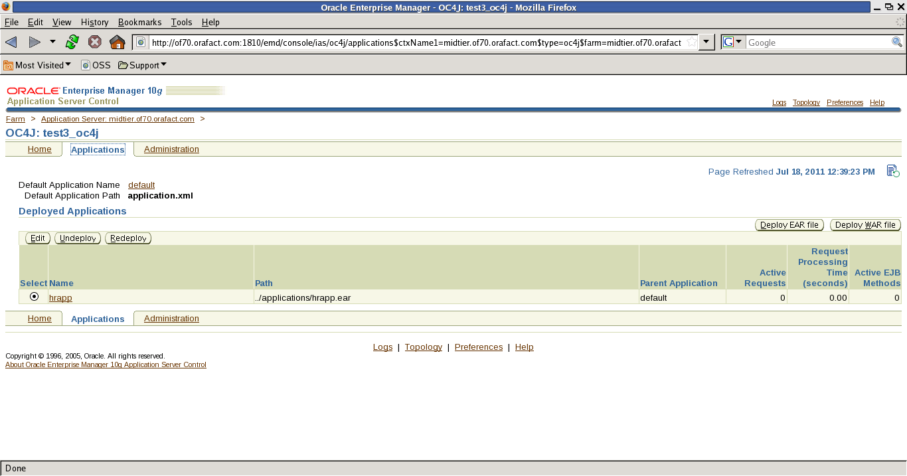

After deploying the ear file go to midtier application then click on administration in that page click on datasource link.

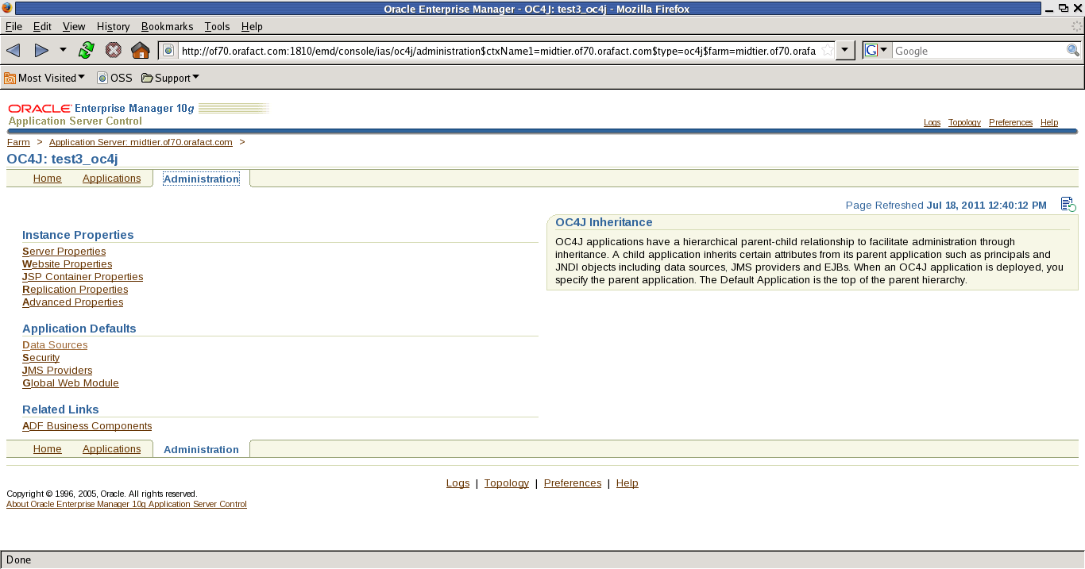

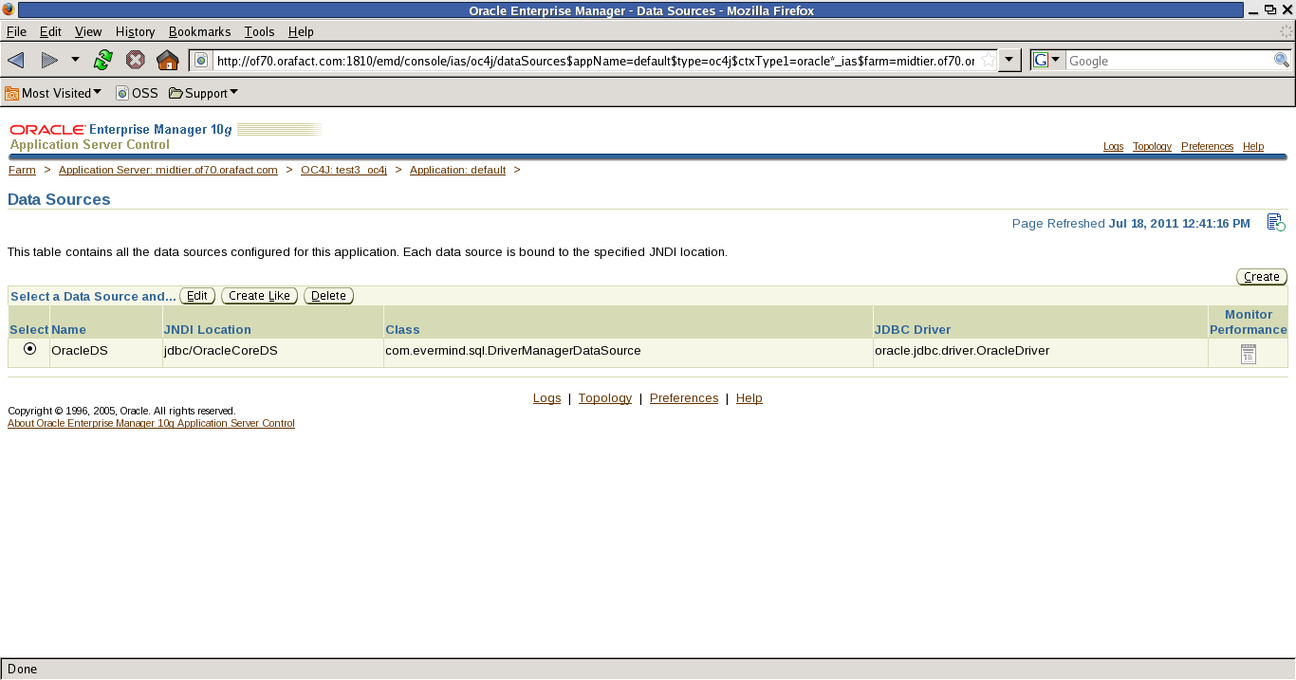
When you get datasource browser click on edit .

After getting this window you have make some changes, in jdbcurl
give like this [jdbc:oracle:thin@localhost1521:infra
then give username :scott
password :tiger
then edit location :[jdbc/oracleds]
transaction location [jdbc/xa/oracleds] then click on [yes]
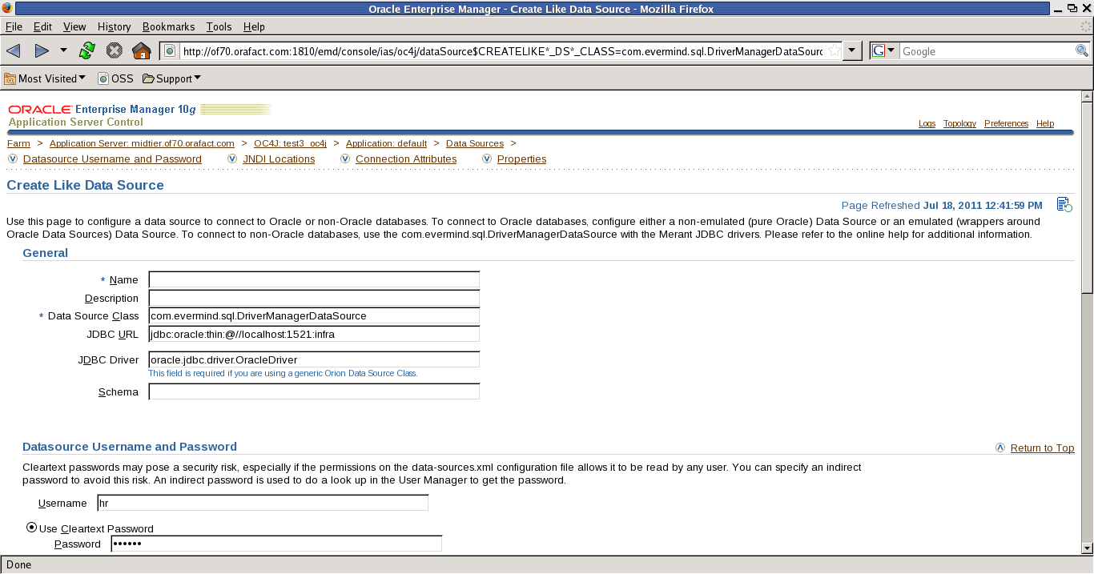

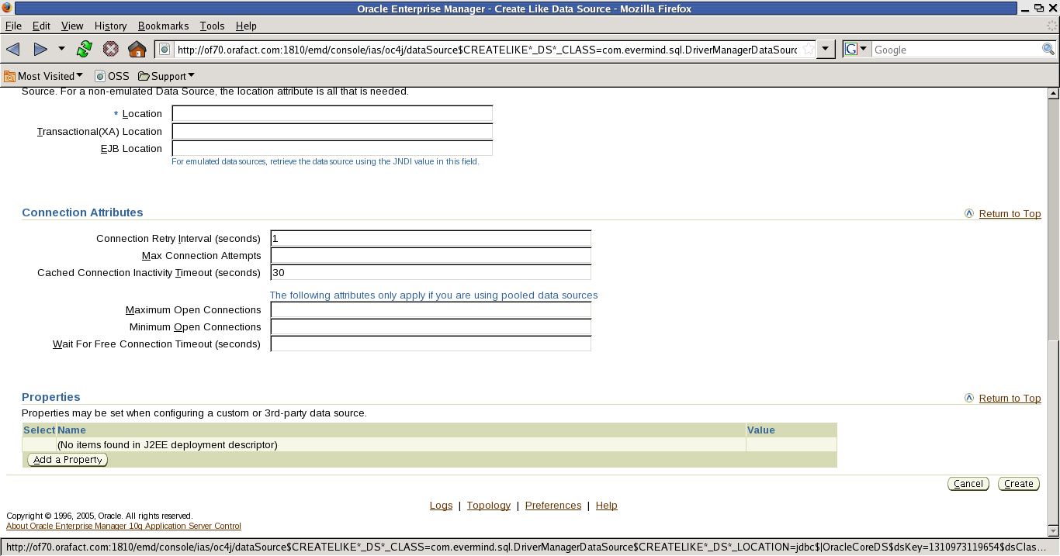

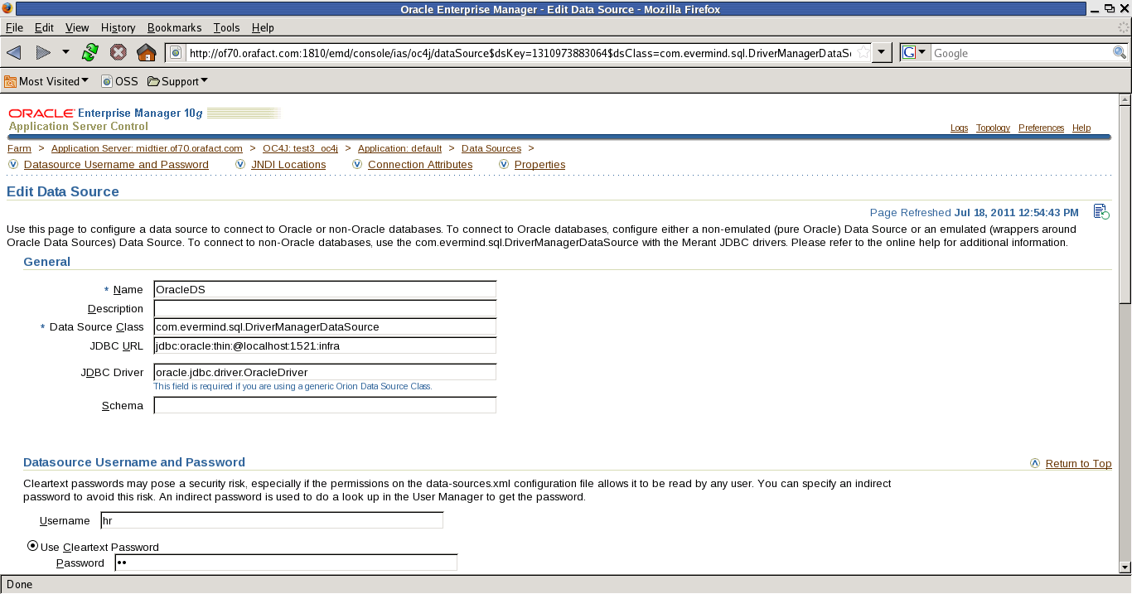
after editing the information then click on ok.

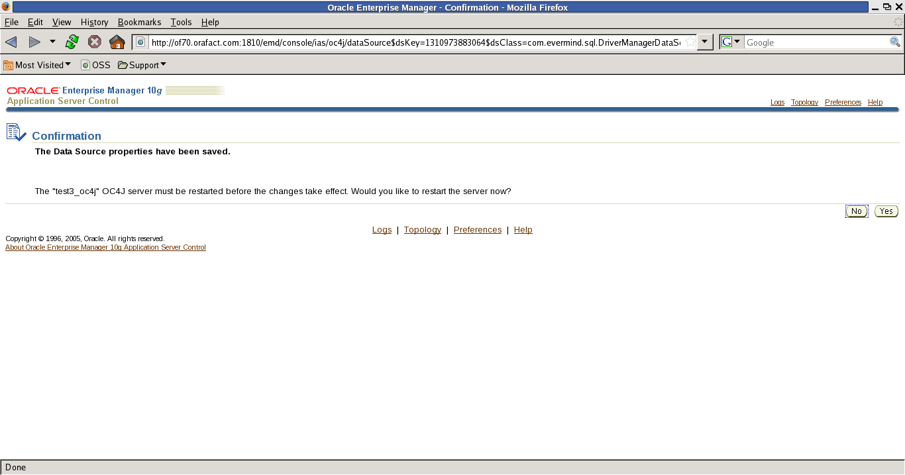

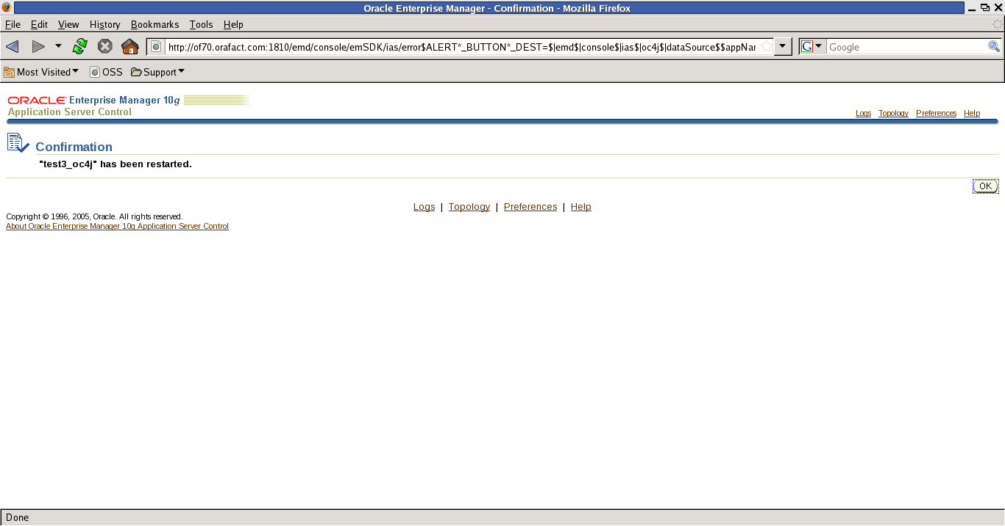

after completion of all these thing then open the browser then give the URL location.
Http://of70.orafact.com:7779/hremp (hremp short url what you have given before) using that we can get the hr application.
You will get the screen like this then by clicking on tabs you will get the details.

